Planning Logic
Sprint Planning & Story Point Estimation:
The project is planned using an Agile Sprint-based approach. The complete project is divided into smaller Epics, and each Epic is further divided into User Stories that can be completed within a sprint.
Story points are assigned based on the complexity, effort, dependencies, and implementation time required for each user story. The Fibonacci-based scale 1, 2, 3, and 5 is used, where 1 represents a very easy task and 5 represents a difficult task.
The stories are prioritized so that the most important functionality, such as request submission, dynamic forms, automated workflow, approval, and record creation, is completed first. Features such as tracking, team management, reporting, and supporting administration are planned for the following sprint.

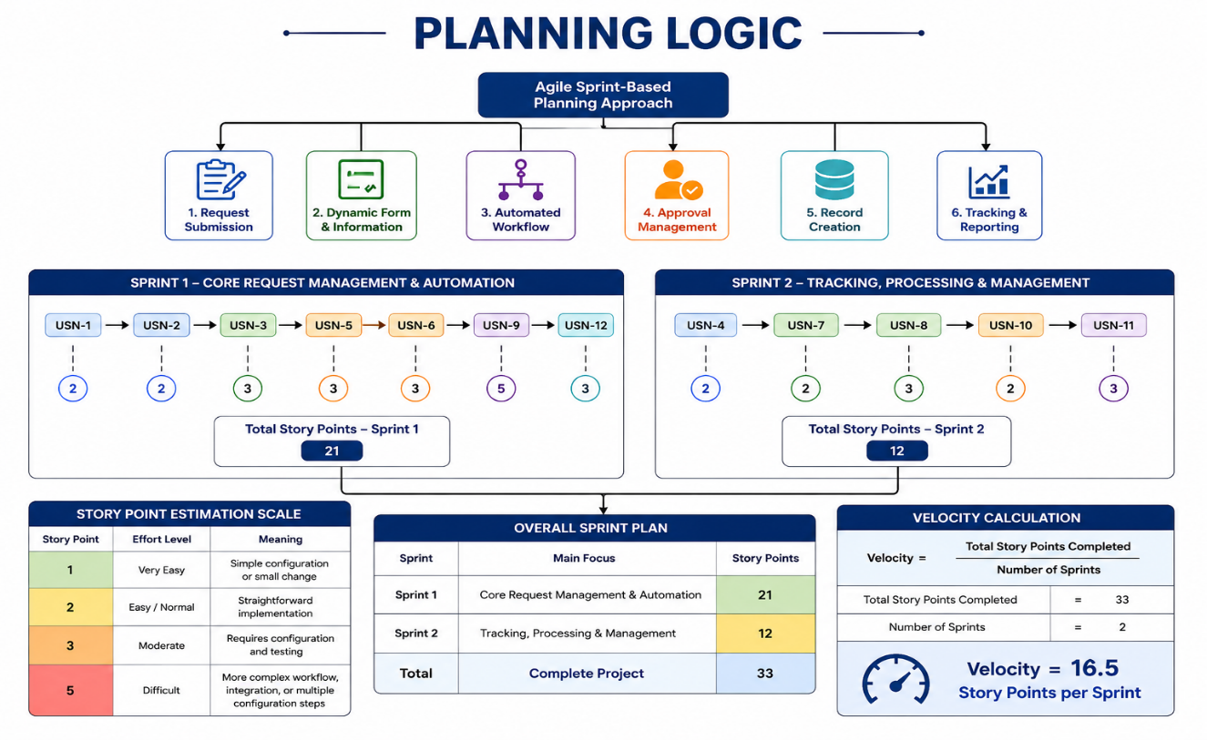

Story Point Estimation:
Story Point | Effort Level | Meaning
1 | Very Easy | Simple configuration or small change
2 | Easy / Normal | Straightforward implementation
3 | Moderate | Requires configuration and testing
5 | Difficult | More complex workflow, integration, or multiple configuration steps

Sprint 1 – Core Request Management & Automation:
Sprint Goal: Build the basic network request process, including request submission, dynamic information collection, approval, automated workflow, and record creation.
Epic | User Story | Description | Story Point
Epic 1 – Request Submission | USN-1 | Employee submits a Network Request through the Service Catalog | 2
Epic 1 – Request Submission | USN-2 | Employee enters connection, address, device, and requester information | 2
Epic 2 – Dynamic Request Form | USN-3 | Display relevant fields based on request/device selections | 3
Epic 3 – Approval Management | USN-5 | Approver reviews, approves, or rejects the request | 3
Epic 3 – Approval Management | USN-6 | Automatically generate and process the approval request | 3
Epic 4 – Workflow Automation | USN-9 | Flow Designer automatically processes the request workflow | 5
Epic 5 – Record Management | USN-12 | Automatically create a Network Request record from the submitted request | 3
Total Story Points – Sprint 1
2 + 2 + 3 + 3 + 3 + 5 + 3 = 21 Story Points
Sprint 1 Total = 21 Story Points

Sprint 2 – Tracking, Processing & Management:
Sprint Goal: Complete request processing by adding status tracking, support-team processing, administrative management, and reporting.
Epic | User Story | Description | Story Point
Epic 6 – Request Tracking | USN-4 | Employee can view the current status of the request | 2
Epic 7 – Team Processing | USN-7 | Network Support Team receives approved requests | 2
Epic 7 – Team Processing | USN-8 | Network Support Team processes the request and updates its status/resolution | 3
Epic 8 – Request Administration | USN-10 | Administrator views and manages Network Request records | 2
Epic 8 – Reporting | USN-11 | Administrator generates reports for request monitoring | 3
Total Story Points – Sprint 2
2 + 2 + 3 + 2 + 3 = 12 Story Points
Sprint 2 Total = 12 Story Points

Overall Sprint Plan:
Sprint | Main Focus | Story Points
Sprint 1 | Request submission, dynamic form, approval, automation, record creation | 21
Sprint 2 | Tracking, team processing, administration, reporting | 12
Total | Complete project | 33

Velocity Calculation:
Velocity represents the average number of story points completed by the team during each sprint.
Total Story Points = 21 + 12 = 33
Number of Sprints = 2
Velocity = Total Story Points Completed ÷ Number of Sprints
Velocity = 33 ÷ 2
Velocity = 16.5 Story Points per Sprint
Therefore, the team's estimated average velocity is 16.5 Story Points per Sprint.

